-PRESS RELEASE- Morelia, Michoacán, October 10th, 2017.

Al Gore to attend the 15th FICM
as a special guest

The 15th Morelia International Film Festival (FICM) will be honored to welcome former US Vice President Al Gore as a special guest. After a long and successful political career Al Gore decided to put all his energy, intellect, resolution and voice, to face the increasingly alarming and pressing global crisis climate change. One of the results of his efforts was the Oscar®-winning documentary, An Inconvenient Truth, in which filmmaker Davis Guggenheim followed the former US Vice President in his campaign to raise awareness of the problem.

Eleven years after the release of An Inconvenient Truth, former US Vice President Al Gore will attend the 15th FICM to present the sequel to this powerful documentary: An Inconvenient Sequel: Truth to Power, directed by Bonni Cohen and Jon Shenk. Thanks to the support of Paramount Pictures and Participant Media, the public of Morelia will be able to enjoy this documentary that has already been presented at both, the Sundance Festival and the Cannes Film Festival.

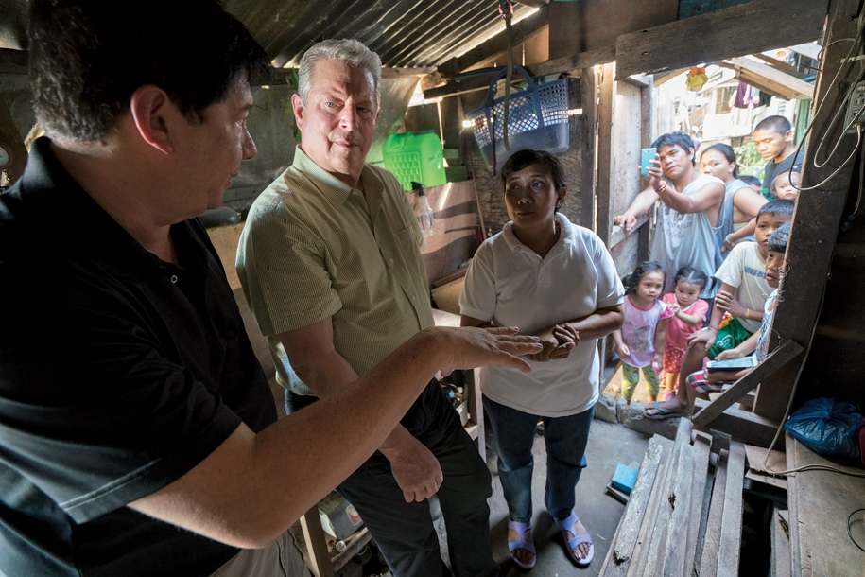
An Inconvenient Sequel: Truth to Power, de Bonni Cohen y Jon Shenk.

Daniela Michel, founder and director of FICM, said: "It is a privilege to have a figure like Al Gore, who has dedicated much of his life to the fight for an urgent cause as the protection of our environment is, and who has known to use the power of cinema to transmit his message ".

Currently, Al Gore is co-founder and chairman of Generation Investment Management. He is a senior partner at Kleiner Perkins Caufield & Byers, and a board member of Apple Inc. Al Gore devotes much of his time to the chairmanship of The Climate Reality Project, a non-profit organization he founded that focuses on finding solutions to the global climate change crisis. He is the author of the bestsellers Earth in the Balance, An Inconvenient Truth, The Assault on Reason, Our Choice: A Plan to Solve the Climate Crisis, and most recently, The Future: Six Drivers of Global Change. He was the 2007 Nobel Prize Laureate for “informing the world of the dangers posed by climate change.”
###
Press Contact:
Margarita Fink
margarita.fink@moreliafilmfest.com
Cel. 04455-5405-9998
More information:
www.moreliafilmfest.com
Facebook: moreliafilmfest
Twitter: @FICM
#15FICM

